**GenAI**

**CA-II**

**Assignment**



**Name: Mayank Jichkar**

**PRN: 21070521040**

**Section: A**

**Q:4 Generate a model to represent interest calculations of a Bank account where the process of**

**calculating interest for 6 months is a. Find minimum balance for each month b. Make a total of**

**all minimum balances c. Calculate interest based on interest rate d. Divide interest by 12 to**

**find one-month interest e. Multiply interest by 6 to show interest in the account. Generate a**

**model to represent transactions and interest calculations for 6 months.**

**Solution:** Flowchartto understand the flow of solution for the problem statement given.

**START**

**Initialize Bank Account with Initial Balance**

**Simulate Random Transactions for Each Month (Deposit/Withdraw)**

**Find Minimum Balance for Each Month**

**Sum Minimum Balances**

**Calculate Interest Based on Annual Interest Rate**

**Divide Interest by 12 for Monthly Interest**

**Multiply Monthly Interest by 6 to Get Total Interest for 6 Months**

**Print Interest and Minimum Balances**

**END**

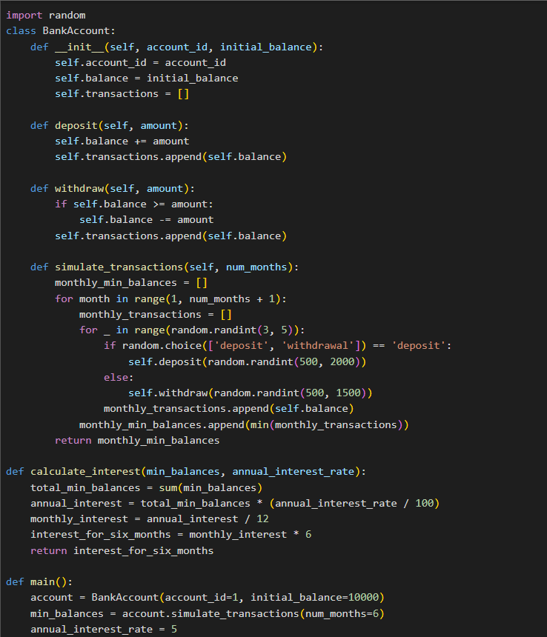**Code:**

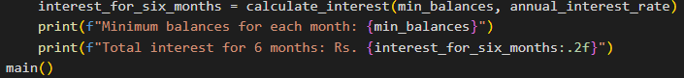

**Output:**

**Q:5 Generate a model for Covid 19 with symptoms of parameters like fever, cold, shivering, weight loss, generate 100 model data with random values for each parameter.**

**Solution:** Flowchartto understand the flow of solution for the problem statement given.

**START**

**Generate random data for 100 individuals:**

**-Fever (0-10)**

**-Cold (0-10)**

**- Shivering (0-10)**

**- Weight Loss (0-10)**

**Store data for each individual**

**Ask user for symptom to sort by (Fever, Cold, etc.)**

**Sort the data based on selected symptom**

**Display sorted data**

**END**

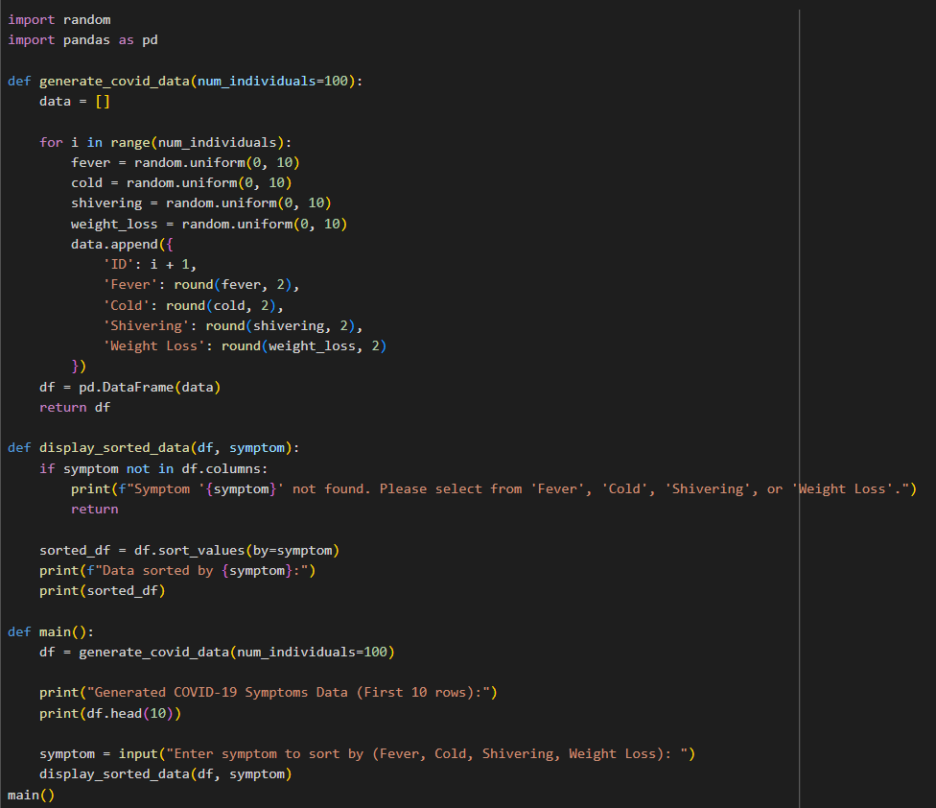**Code:**

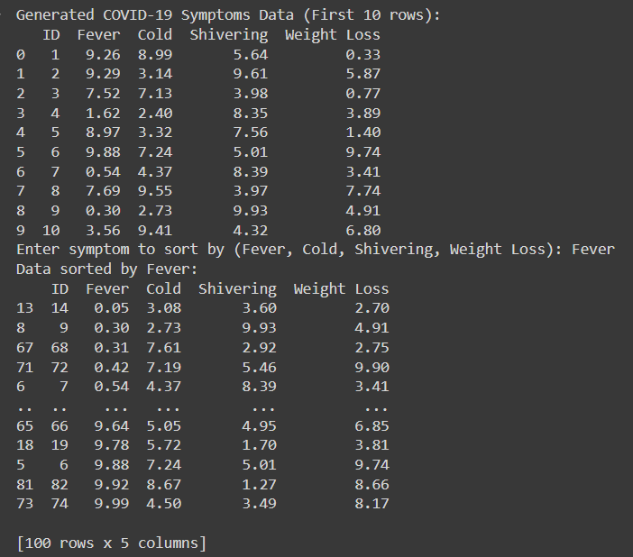

**Output:**